# PandoLogic Algo - Tech Tasks

**General Notes**

### Thank you for applying to PandoLogic Algo department. The next step in the hiring process is a home tech test.

### Please approve receiving this email and provide a time estimation for your solution.

### Please send a well format standalone .NET project that can be ran & debugged on a standalone machine.

The SQL scripts to create the relevant DB entities for the solution are attached.

### For any additional information please email to: ygoldfine@pandologic.com

**Good Luck!**

**Task #1**

Create a web page containing the section described below with the following functionality:

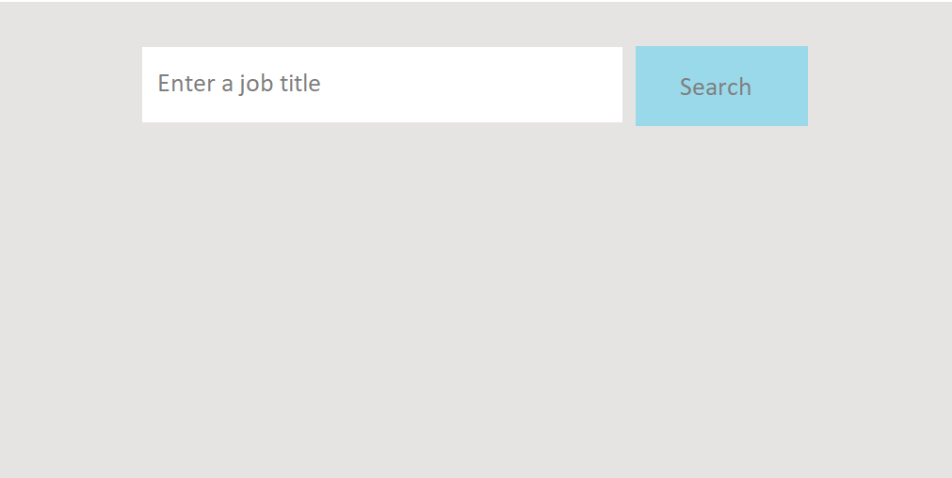

The text box should have auto-complete abilities presenting a dropdown list on every character input starting  
 from 2 characters.

F.E – the input 'd' should have no output, the input 'dr' should have results – driver, driller etc.

Click on 'Search' will load a list of relevant jobs with the selected job title to the page.

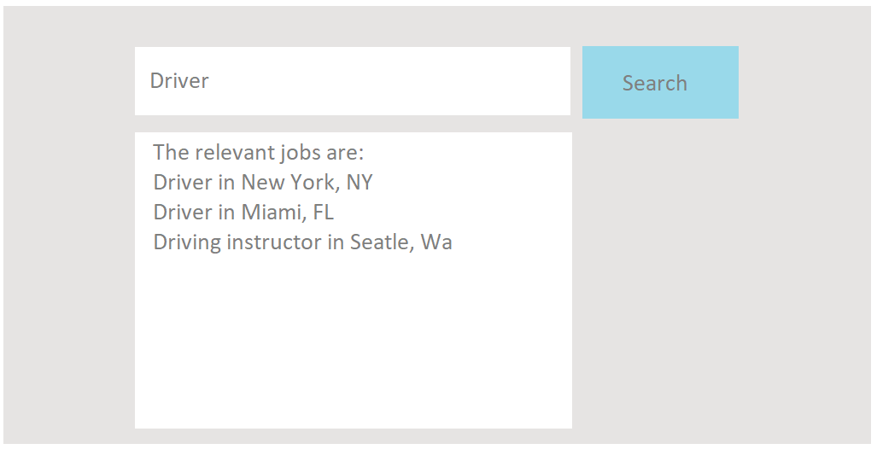

The data entity for the autocomplete is – [Test_JobTitles].

The data entity for the results is – [Test_Jobs].

The relevant scripts are attached.

**Good luck.**